**Project 1 :**

Demonstrate Build Other Projects when one project build succesfully in jenkins using maven build tool and also define pipeline view.

Details :

* First we need to configure for maven , so from the jenkins dashboard first we click on manage jenkins option.

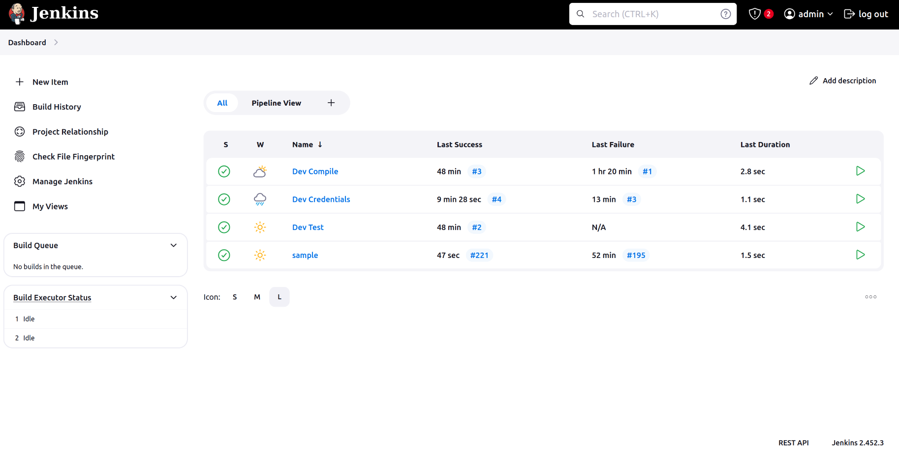

* Then Click on Tools.

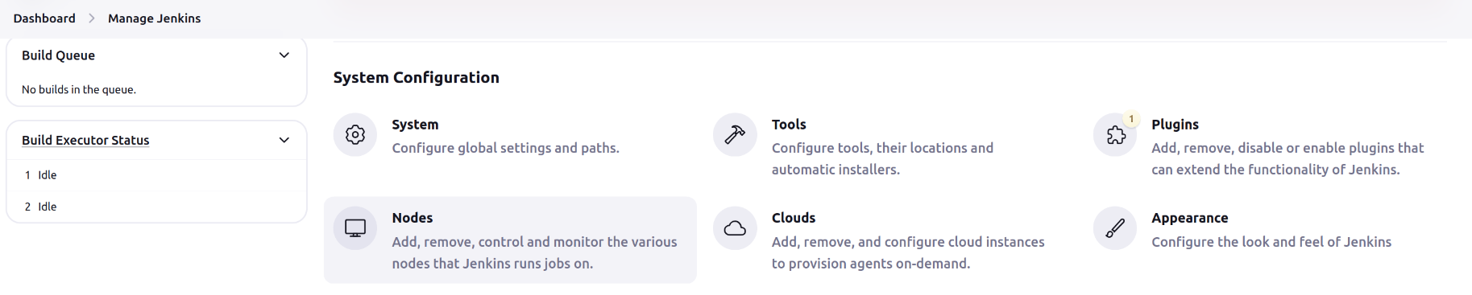

* Then after scroll down and go to Maven installations and select maven version and give name.

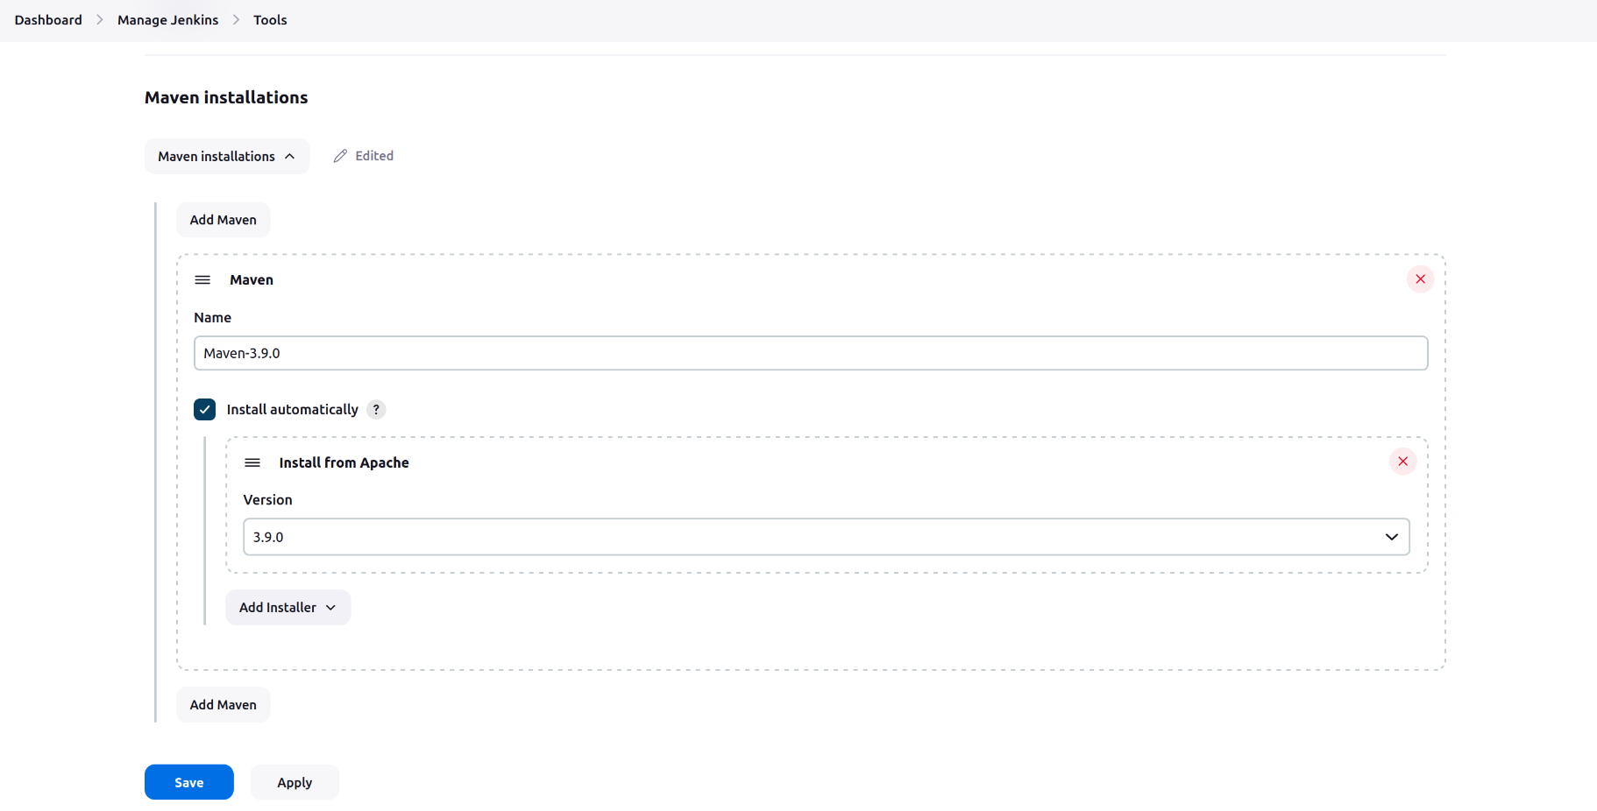

* After that we need to install plugin for pipeline view called “Builed Pipeline” . For that we need to go inside plugins menu which is shown in second step.
* Inside that go to availabe plugin search for plugin and installed it.

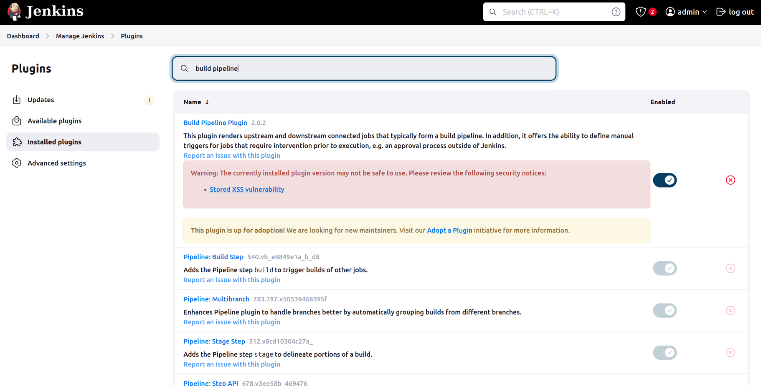

* Now go to dashboard create new free style project let’s name it Dev Test.
* Now here we provide git repository and we here don’t want to automate the build so we leave all the option as it is.
* Now inside Build Steps we choose Invoke top-level Maven Targets option and select maven version and then inside goals we define it as a test.

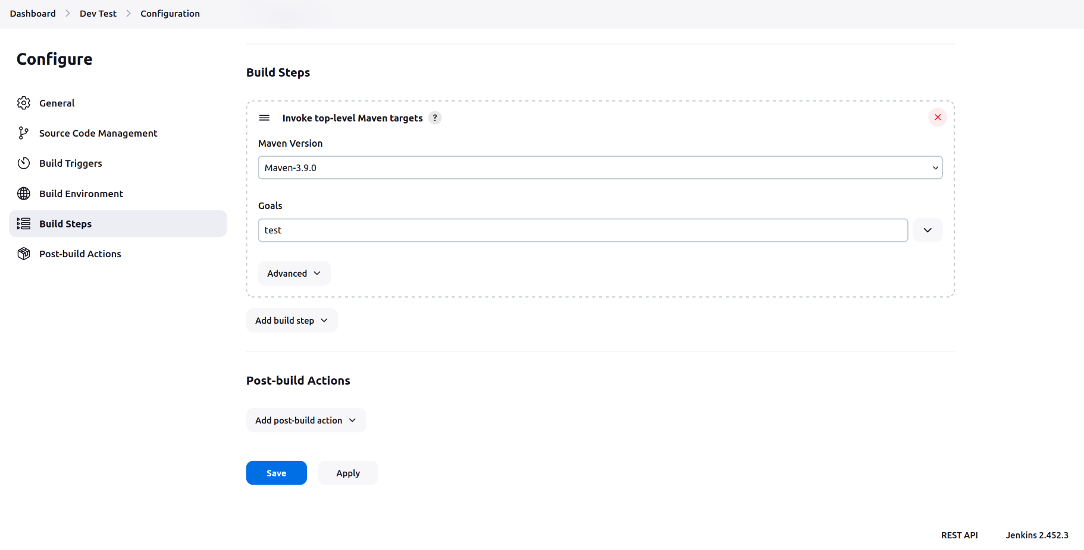

* After that we create one more project called Dev Compile and follow same process as above but we here give name goal as compile and also we want that when this build finish then automatically Dev Test project.

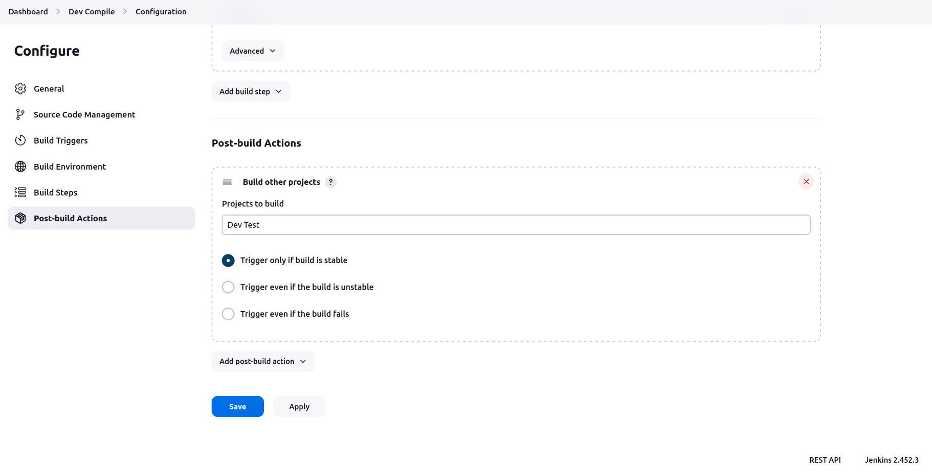

* Here we specify project name which we want to build on and by clicking first option we ensure that if this build is succeed then and then only another build provokes.Now we build the Dev Compile project and we can see that test project is automatically built but we see it in the pipeline view for that we follow below steps.
* Now for seeing this process in pipeline view we go to the dashboard and then click on + icon above the project list.(refer first screenshot)
* Here scroll down and inside Upstream/downstream config we choose project which triggers another project build.
* Restrict triggers to most recent successful builds . If its set to no then display button on all successfull build else it displayed on most recent successful build.
* Always allow manual trigger on pipeline steps. Select this option if you want to be able to execute again a successful pipeline step. If the build is parameterized, this will re-execute the step using the same parameter values that were used when it was previously executed.

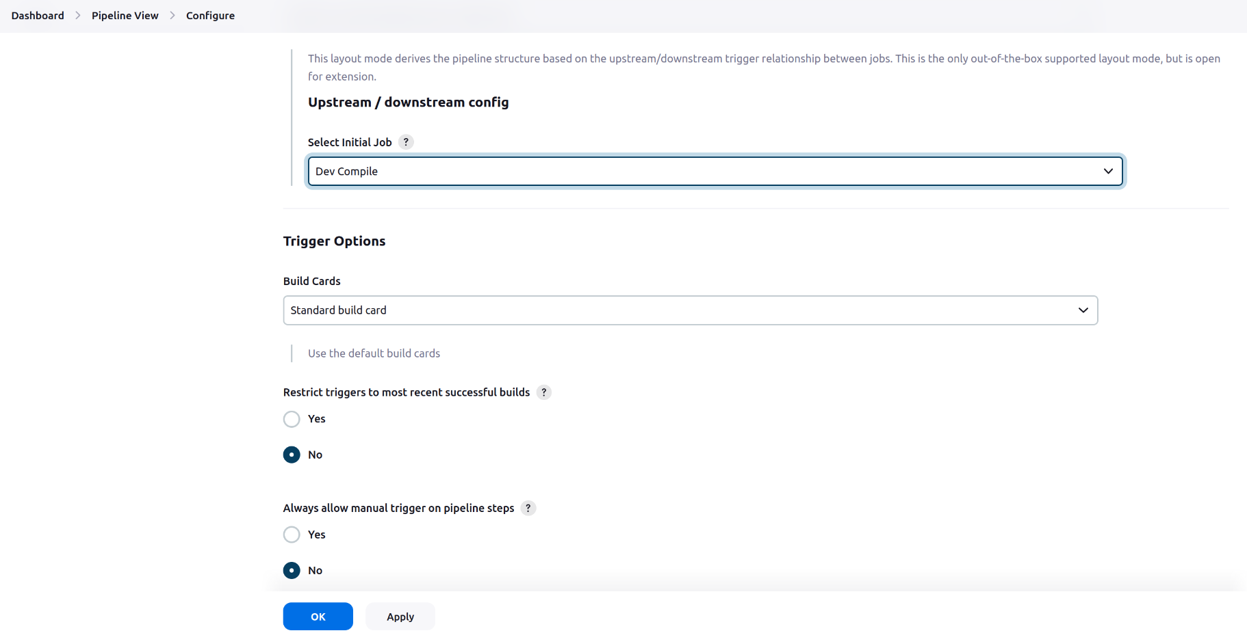

* Inside Display Options we define No of Displayed builds which means how many success or failed builds displayed as pipeline view.
* Row headers and Column headers are for displaying specific information in view.
* Refresh frequency is frequency at which the Build Pipeline Plugin updates the build cards in seconds.
* Url from custom css files is for define custom layout of view.
* Console output Link Style means Generated log is displayed in which manner.

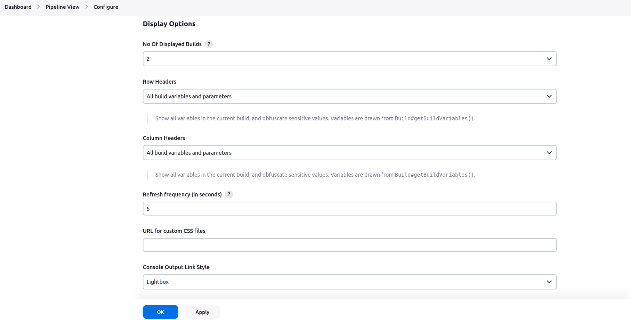

* Now we click on ok and we can see pipeline like view.

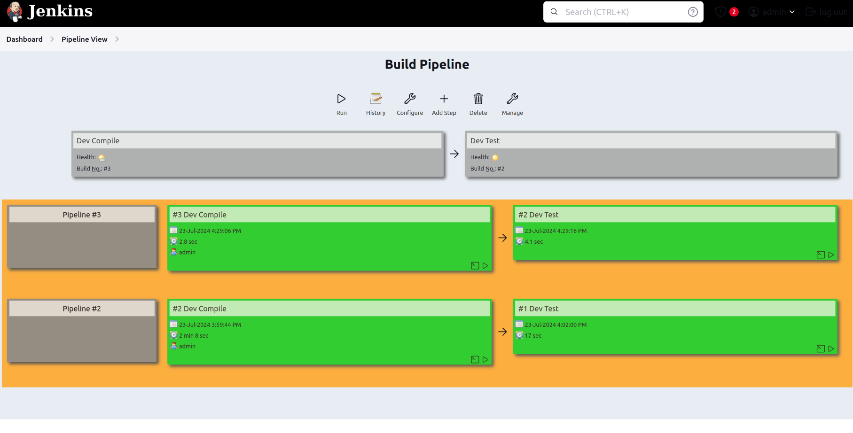

**Project 2 :**

Demonstrate Accessing github private repository through credentails in jenkins.

Details :

* We follow the same process of above of creating free style project but we don’t configure maven because here we use git repository which has shell script.
* First inside Credentials Field we click on add button and choose jenkins and here use github token as username and password and we make here this credential as global so it is availabe to everyone.

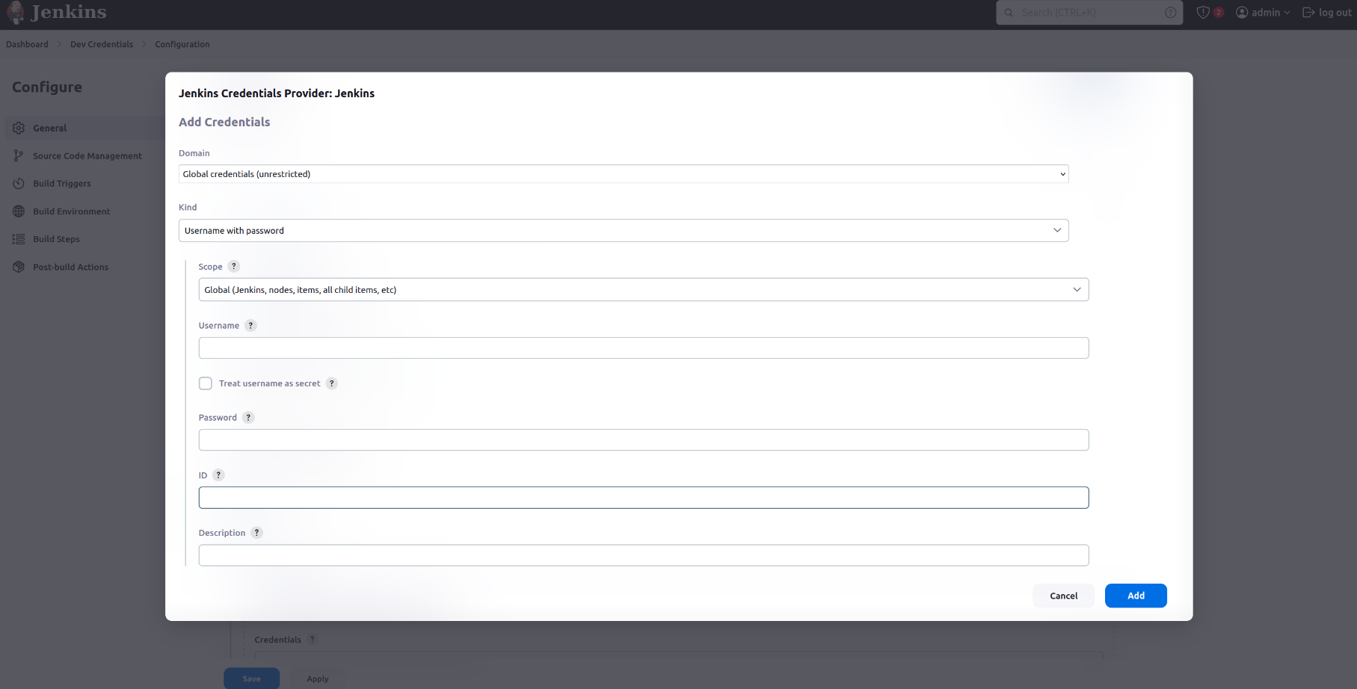

* And then select added token.

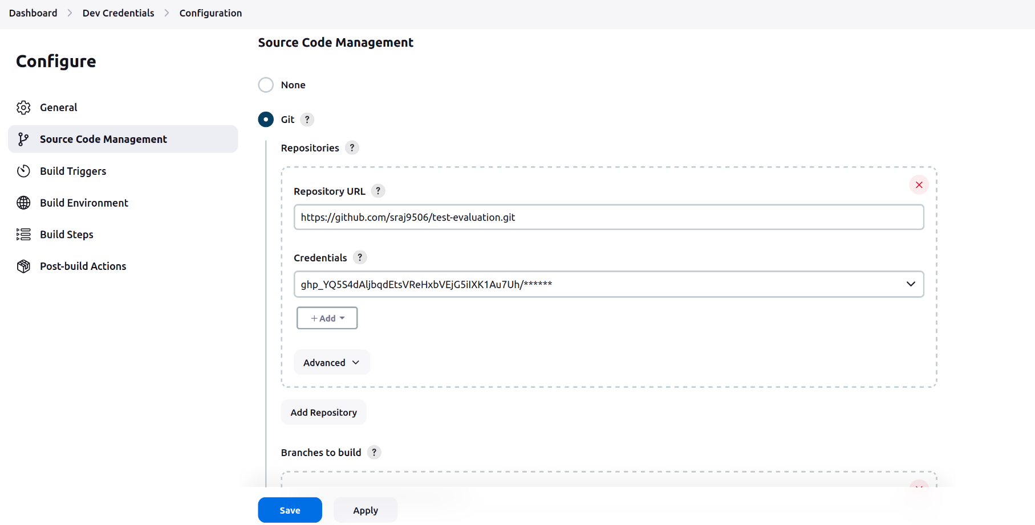

* Here we want to execute shell script so that in build step we need to give permission of execute and command of execute and along with that i pass parameter to it.

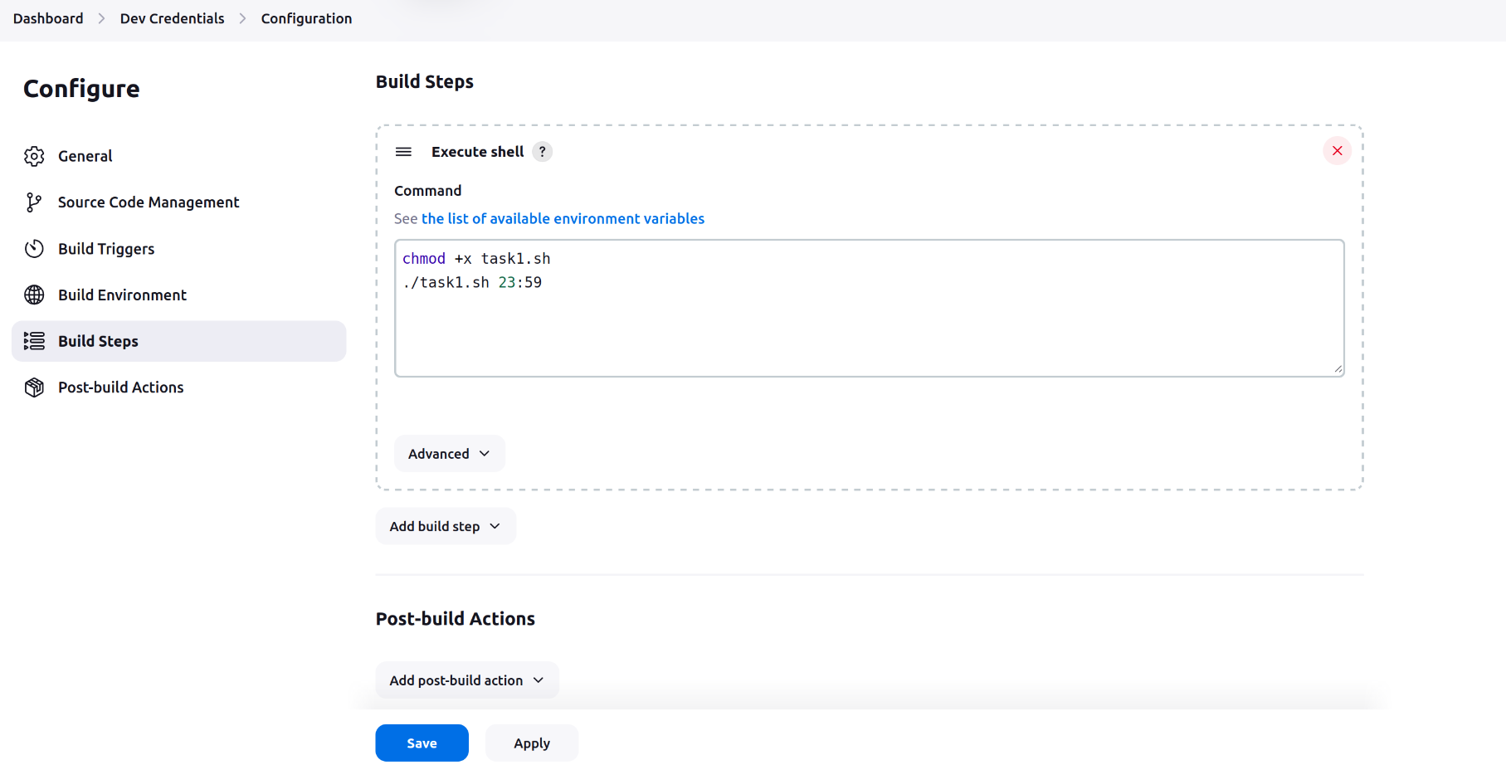

* Below is the console output of script .

